Student Housing BV

By

Ioan-Nicolae Popa

Matei-Cristian Mitran

Alexander Bogdanov

Fontys University of Applied Science

Software Solution for student houses

ICT & Software Engineering – Advanced project

Introduction

After finishing semester 1 orientation phase and the introduction project we are met with our first advanced phase project that will kick start our dive into what it means to be a true software engineer.

The aim of the project is to create a user-friendly app that can be used by people that share a common living space in order to interact with each other in a way that allows them and the land lords to keep track of day-to-day tasks and announcements. More than that, we aim to create a strong bond between the tenants using a system that rewards good behavior and task fulfillment, and sanctions the misconduct of the house rules.

We have been allocated a time span of 6 weeks after which we have to deliver the fully working program. Meanwhile, we have to get ready our first draft of the app in approximately 2 weeks after the start of the advanced phase.

Student Housing BV

Objectives

When Student Housing BV approached us to create this app, they made a brief explanation of all the problems and necessities that clients go through when staying in one of their locations.

In their circuit of houses, they have a set rules that need to be followed:

* Once a week, one of the people living in the house is tasked with taking care of the groceries, meaning that each month the tenants put 1 euro each in the piggy bank in order to make enough money to buy paper and detergents for a whole month. We must come up with a way for someone to be chosen to take care of groceries.
* Cleaning after you are done using any of the facilities offered by the housing agency is a must, but some people seem to forget that and leave a mess for the next person to clean. We think our report system will prove useful, since we though of a way to report usual misconduct that usually takes placed and also for personalized reports.
* Since most of the people living in the housings offered by the company are students, parties are no foreign concept. They usually take place without the consent of the other tenants and end up being an annoyance for the others. We also need to create a nice environment for announcements where people can see the schedule for upcoming parties and gatherings. Users will be able to vote on proposal of such activities and depending on the agree to disagree ratio, the event takes place or not.

Implementation

* 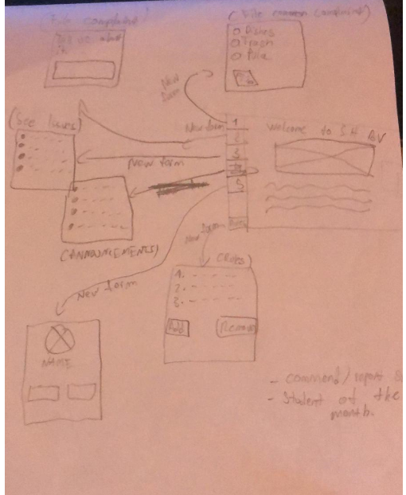We will have a log in screen that will let you log in as an existing tenant or log in as an admin, since Student Housing BV requested that announcements are to be made by members of the staff regularly. Logging in as a tenant will allow you to make use of the main page that will have a nice user-friendly interface. On this page multiple buttons will make navigation easy and seeing announcements easier. We are allowed to have full creative expression so multiple details and updates will be added.
* Logging in as and admin will let you delete and update the “Rules” of the selected house, making it easy for employees of Student Housing BV to hop in and make a few changes from time to time. We are thinking of ways of having a tighter bond between user and company, so we will also have to look into that in the process

Timing

Since our team is made out of 3 software engineers, we will have to split the work evenly between ourselves. We also have to keep in mind the time restraints that are set in place by the company. We are to deliver the fully working application by the end of January.



Impediments

One of our biggest concerns regarding the app is the misuse of the report system. Originally, we thought of a report system that will put a tenant under surveillance if it has been reported more than 10 times. This process can easily be abused and we thinking of ways to avoid those kinds of situations.